**Lab 6: Classes and objects manipulation**

The below UML are made using https://creately.com/.

1. **Program 6.1**

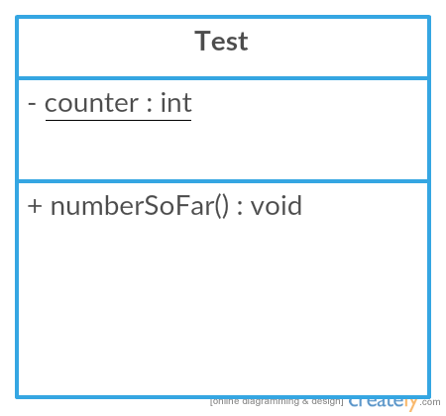

**Program 6.2**

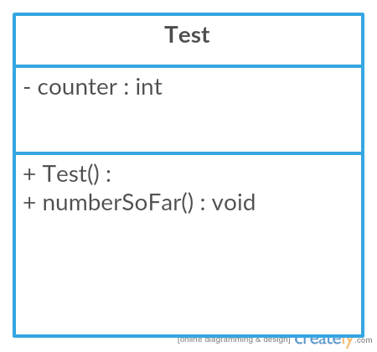

1. **Program 6.3**

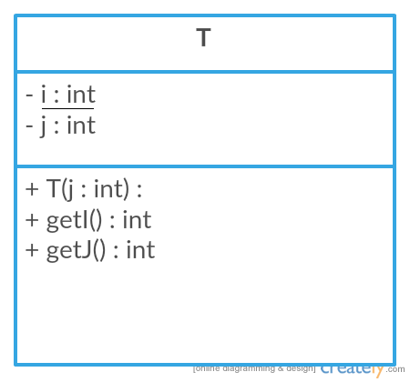

**Program 6.4**

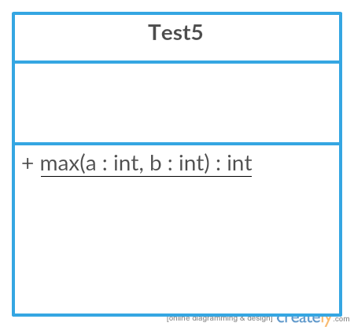

1. **Program 6.5**

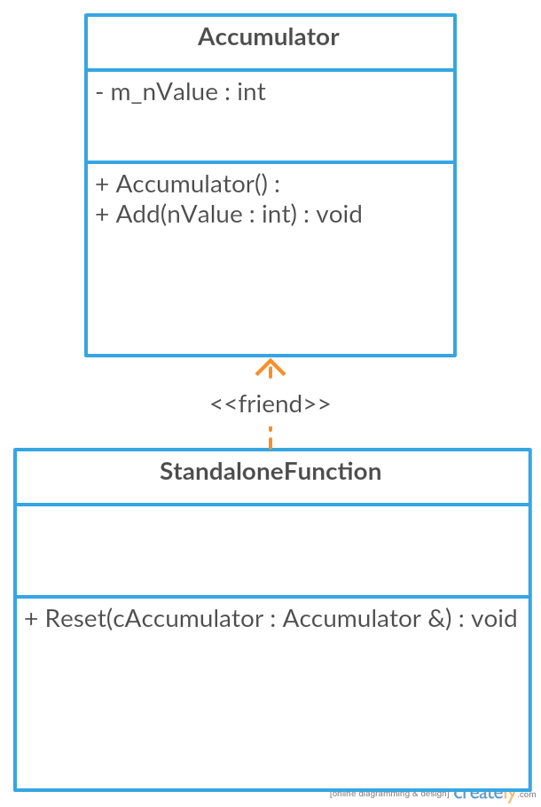

1. **Program 6.6**

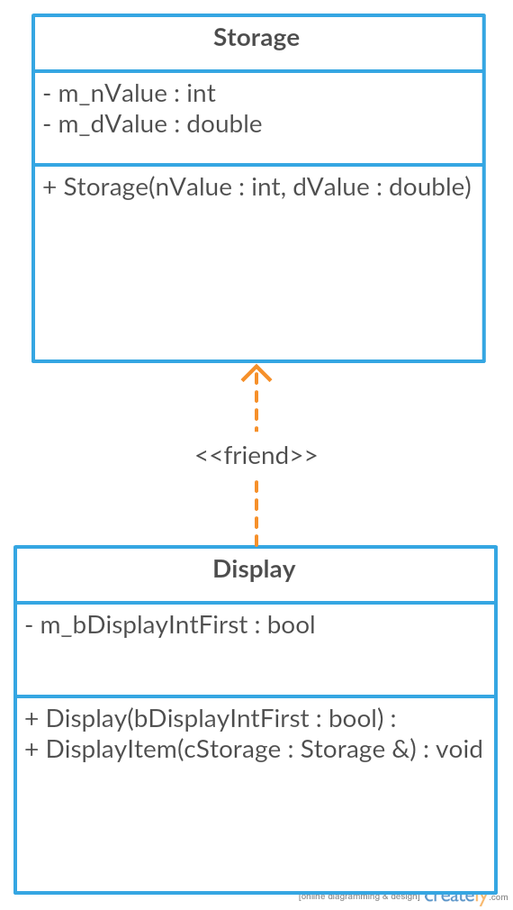

1. **Program 6.7**

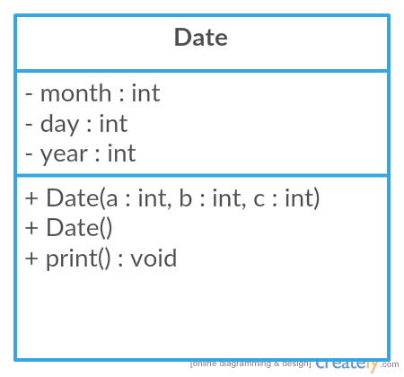

**Program 6.8**

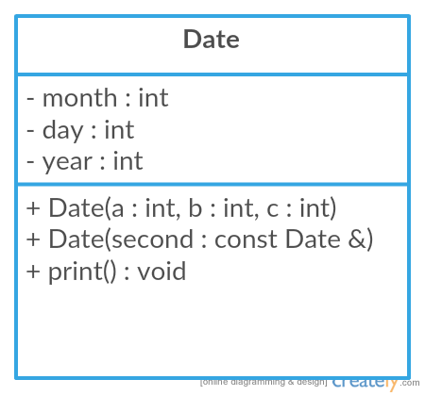

1. The corrected code is at Lab 6: Answers & Codes in front.

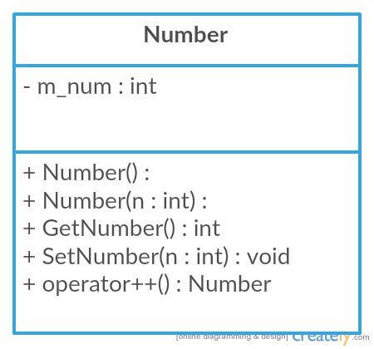

**EXERCISE 2: STRUCTURED PROBLEMS**

1. **Program 6.9**

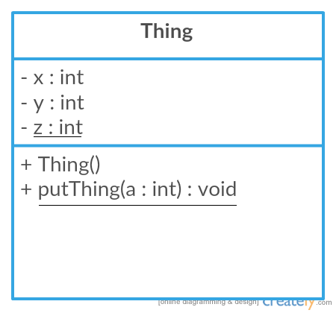

1. **Program 6.10**

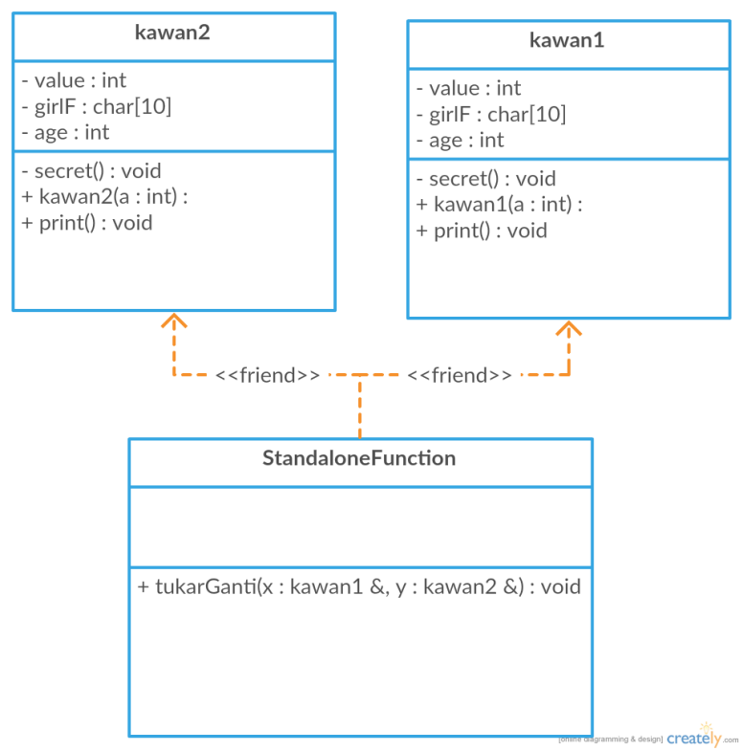

**Program 6.11**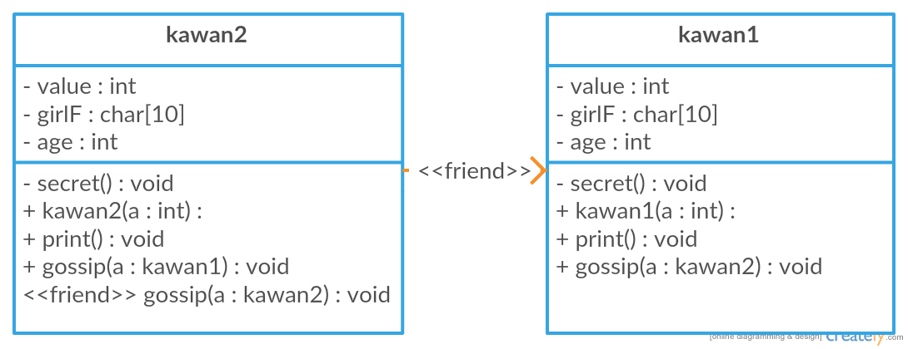

1. The code is in front.

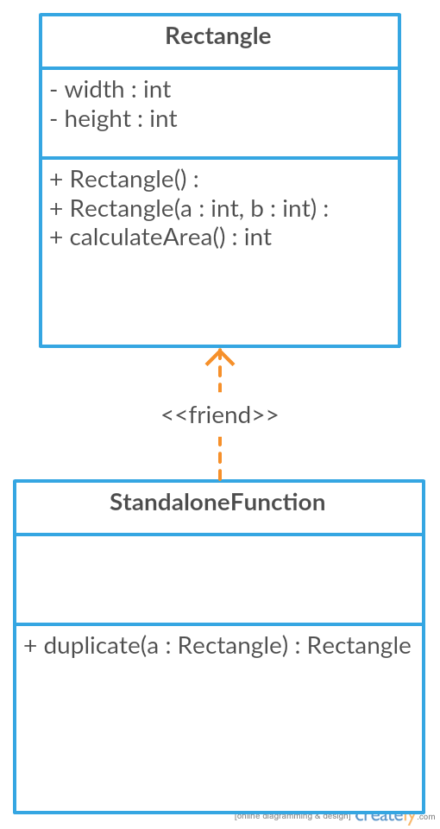

1. The code is in front.

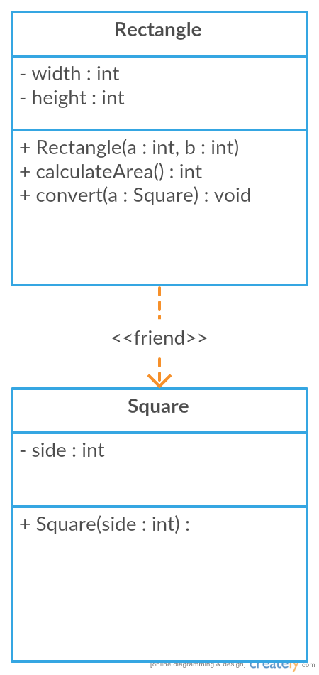

1. The code is in front.

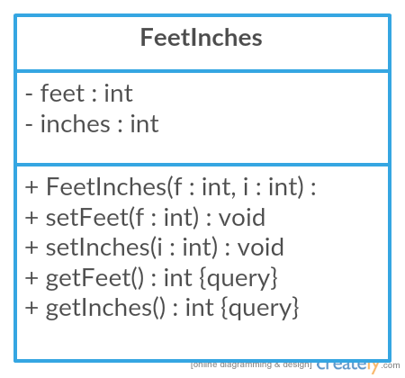

1. **Program 6.14**

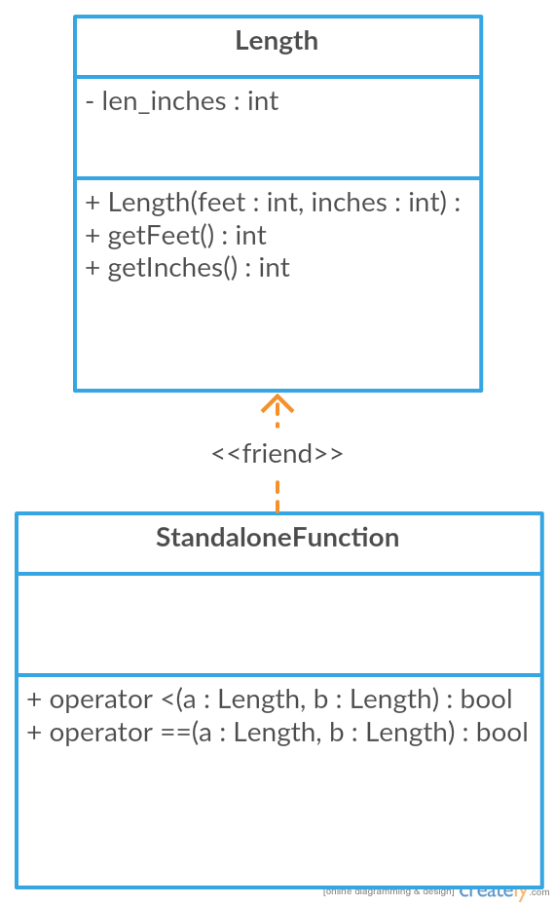

**EXERCISE 3: PROBLEM SOLVING**

1. **Program 6.15**

